School Services Newsletter
Spring Term 2022
Dear Families,

With Spring in the air, daffodils blooming and blue skies uplifting our spirits (with a few snow flurries thrown in for good measure) I am delighted to be sharing this term’s newsletter with you with Easter around the corner. Every term at Pace tells a story. For me, Spring term 2022 tells a story of both hope and of loss. Hope – for the arrival of Spring, a light at the end of the tunnel for Covid 19 challenges and the promise of lighter days and warmer weather to boost our mood and our spirits. Loss – for our friends who are no longer here with us who we miss dearly. Spring 2022 has also told a story of friendship, love and support within our Pace community – tenacity and resilience, aspiration and courage.

Throughout it all, Pace students have shown up and worked hard. The latest round of goal reviews have blown us all away in terms of the progress made. But it has not been easy and there is still much to be done. The legacy of our shared challenges over recent years with the pandemic is still very much impacting on many members of our Pace community in terms of anxiety, illness and relationships. We are working hard to support each other, and particularly to strengthen our curriculum offer in relation to social emotional and mental health support for both students and staff. This is described in more detail by our Lead OT Jo Elliot later in the newsletter.

Some highlights for me this term have been World Book Day, where students had staff had immense fun celebrating books and their favourite characters, art theme days in collaboration with MKGallery where artists sent personalised boxes of art materials for our students to use to create their own incredible artwork and the day that a former student visited our secondary students which left them feeling inspired and in awe of his achievements. These are just a handful of the way our existing integrated curriculum has been enriched to engage and excite our students. Hopefully you have all seen the message about the Art Exhibition being put on by some of our secondary students at MKGallery. Please do attend and show your support if you can , it is on between 10.00am and 7.30pm tomorrow (5-4-22) . You are sure to be impressed by the art that is on display and all of the hard work and careful planning that the students have put in to put on the exhibition!

This term’s newsletter offers a snapshot of some of the other joyful activities that have taken place, along with accounts of the steely determination and resilience demonstrated by Pace students, described by each professional group of our transdisciplinary staff team. There is also a message from our ‘Pace Parent Partnership’ (PPP) at the very end which I would like to draw your attention to.
With the acceleration of our ‘SMART’ provision here at Pace and with the exciting development with our ‘Pace Digital’ project, it is highly likely that the Summer term newsletter will take on a new format and will re-launch via the new Pace Website. Please take a look in Ian Sansbury’s message below for further details about how to get involved. It is such an exciting time for Pace and we can’t wait to share our new online
platforms and resource with you very soon!

I hope you have an enjoyable Easter break and I look forward to welcoming you back for the Summer term.

Claire Smart, Headteacher
A Message from our Chief Executive, Ian Sansbury:

This Spring term has been one of such deeply contrasting emotions. Any term in which we say a sad farewell to one of our students is a hard one, but to lose both Jessica and Annabel in such a short timeframe has brought such a deep sense of grief to the whole Pace community.

Thank you all for your support for each other as we have come to terms with the loss of two wonderful girls. The world is a poorer place without them.

Despite that loss, I continue to be amazed at the resilience of this Pace family. This has been another term of great progress, both within the school (as you’ll read in this newsletter) and across Pace more widely.

Pace Digital is coming closer to its launch (slightly later than originally advertised!) and we are now looking for volunteers to help test the new website. If you’d be interested to do that (and have a sneak preview of the site before anyone else!) do please contact Caroline Bennett (at caroline.bennett@thepacecentre.org).

Pace Digital has given us the opportunity to really set out our stall and describe what we do to the outside world, in a way that we have never been able to before. And so, these recent months have given us the opportunity to refocus on what it is that makes Pace so special – partly so that we can make sure that we keep doing it, but also so that we can encourage others to do it too.

As an indication of the regard in which we are held by other providers, earlier in the term we had a visit from the Chief Executive of another, “sessional” conductive education centre and charity, which is planning to open a school. She was very clear that Pace was the model on which they wanted to base their work – a reminder of the regard in which our practice is held.

And finally, please do get involved in the Pace Big Walk and the Superhero Mile on April 23rd if you can – and do encourage friends and family to do the same. It is always a fantastic day out – and a great opportunity for our Pace community to come together to raise the funds we need to continue all that we do for you and your children. Every year we need to raise in excess of £1 million from charitable sources – and I suspect this is going to be a really tough year for Pace and for other charities. Please help if you can!

Wishing you a very happy and restful Easter holiday – and see you in the Summer!

Ian Sansbury, CEO

Welcomes and Farewells
We would like to welcome the following new members of staff to the Pace team who started during the term and are already part of the Pace community, making a real difference to our children and families in their respective roles:
Emily Christophers, Teacher
Harriet Stacey and Kate Christensen, Learning Support Assistants
Rebecca Fortescue, Occupational Therapist (Child & Family Services)
Biddy Fogg and Andrea Mason, Physiotherapists
Sabrina Lewthwaite, Physiotherapy Assistant (Booker Park School)
Louise Perrin and Kate Lawrence, Play and Independence Care Assistants
Carey-Ann Gee, PA to Clinical Director and C&F Administrator
Jacqueline Morris, Receptionist at Wendover Road

We are also delighted to let you know that Elizabeth Burroughs who has been working in our Child & Family Services was successful in her application for the role of PA to the Board and EHCP Co-ordinator. Elizabeth will be working closely with Shleena Lee, Polly Kempson and Ginnette Field to ensure that our annual review meeting cycle runs as smoothly as possible.

Jenni Westray, who many of you will know as our Receptionist at Wendover Road was also successful in her application for the role of IT Technician and has already proved herself a very valuable addition to the team.
During the term we said, or will soon be saying, a fond farewell to:

Andrew Robertson, Teacher
Taylor Grainger, Learning Support Assistant
Lacey Bonham, Community Fundraiser
Sarah McClellan, Physiotherapist
Sam Gomm, Special School Nurse
Rachel Murrill, Occupational Therapist

Tori Healey has commenced her maternity leave and we wish her well with her new arrival.

News from across the School
Speech and Language Therapy – Fin O’Driscoll (Lead SLT)

It has been great to be in school and seeing all the students in classes over the last term, albeit with rolling absences for staff and pupils thanks to covid and other winter bugs. However, things are looking sunnier at last. The speech and language therapy team are working closely with our colleagues to support our students in communicating about their emotions and concerns following this particularly turbulent period.

In some of our classes, we have teamed up with Occupational Therapy to deliver joint sessions focussing on developing self-esteem and self-identity. Pupils have benefited from discussions around feelings and emotions and are beginning to develop a sense of self, recognising how their emotions vary and considering ways in which they can regulate their own emotions.

We have also been focusing more on peer interaction, specifically with our AAC users who are learning to take turns, ask questions and respond appropriately to their peers. We are using barrier games to facilitate this. Barrier games are a great resource that can be used at home too, if you would like support with this then please don’t hesitate to contact your SLT.

Our Sensory Stories Library is open! We have teamed up with AES (Autism Early Support) carrying out a Sensory Stories Project, which involved creating several of our own Sensory Stories. If you would like to borrow any of our stories to use with your child at home, please get in touch with the SLT Team. These are a great resource to engage your child in a range of stories and allow them to explore sensory experiences associated with the written words.The following titles are available to borrow:
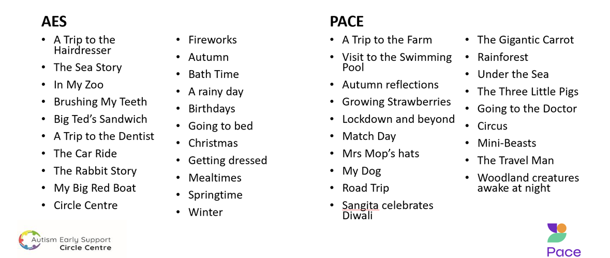

Physiotherapy – Hannah Shelton (Lead PT)
With Spring knocking on our door and the sun starting to makes its first appearance in a while, the Physiotherapy department definintely have a spring in their step with 2 new members of staff joining us this term. Biddy Fogg is joining on our Coventon Road site and will be working mostly in Maple and Willow groups. Andrea Mason has joined us over at our Wendover Road site in Rowan and Oak classes.
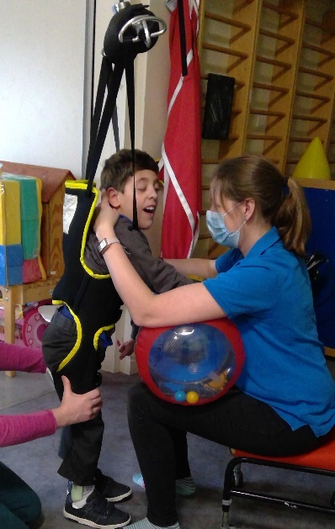
The physiotherapy team are always investigating new products that are out there and new ways of helping our children and young people to achieve their goals. This term we have been thinking about standing and how to help our students get into and maintain standing positions.

Standing is so vital for so many body functions, whether that is circulation and digestion, to help our bone density or whether it is to gain a different view of the world. We have trialled some new standing slings over at Coventon Road this term and our students have had great fun getting up on their feet and showing us how they can stand and step.

The standing slings attach to our overhead hoisting system and free up therapist hands to allow them to influence particular muscle groups that we would want to be working in standing and stepping.

These slings do not work for everyone but we have had great fun trying them and our children have fed back that they were comfortable and helped them stay upright while working on their steps. They are a great tool to have in a therapists box!

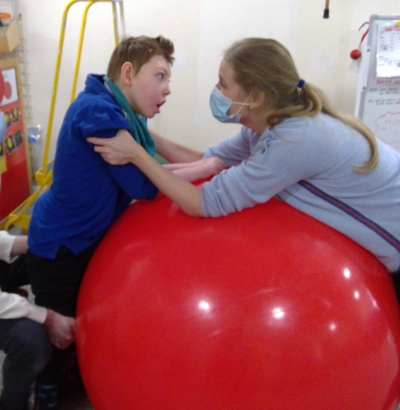
Other ways we have been looking at standing include looking at advances in standing frames and the use of abduction (legs slightly in standing) and how that benefits hip growth and development.

We have asked reps from different companies to come in and demonstrate their equipment to keep us up to date with what is out there and with the vast array of standers it has given us so much more knowledge to help us identify which frames are likely to work for which children and how we can give the children at Pace the best experience of standing possible.

We have also been looking at creative ways of using equipment that we already have at Pace this term to help our children achieve standing in a fun way. A big hit with our children has been facilitating standing with the big red gym ball.

The ball helps the child to keep their knees straight and gives a surface to prop through so that children can work on specific neck and upper back muscles up against gravity while also weight bearing through their legs safely.

The children at Pace have loved using the big red ball in morning groups, before morning programmes or even during lessons over this term and we have seen some wonderful results. Some children have even managed to stand on top of the ball! We can’t wait to see what our children can achieve suing the gym ball over the summer term too!

Conductive Education – Shleena Lee (Lead Conductor)

The spring term has been another busy one for the groups will lots of fun activities happening. On both sites, the Conductors led a ‘Well-being’ day, with each classroom being set up with a different themed activity. From a calm sensory and relaxation space to a fun filled room of swinging and a bouncy castle; a quiet room set up with interactive stories and a variety of crafts, to a lively disco filled with an assortment of light and interactive toys. The children appreciated the opportunity for free flow around the school; making choices of where to go and what new activities to try and enjoyed the chance to meet up and play with students from other classes.

We know all the pupils work hard throughout their day, but the pictures below highlight how learning at Pace can be a little unconventional and so much fun!!
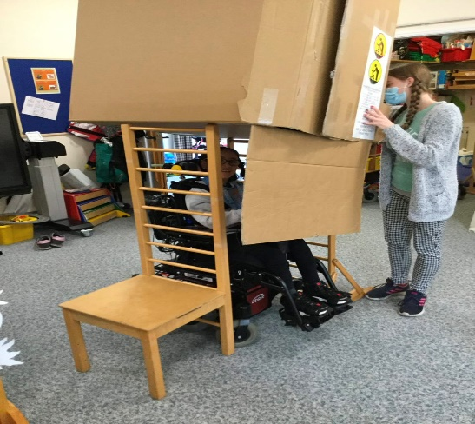
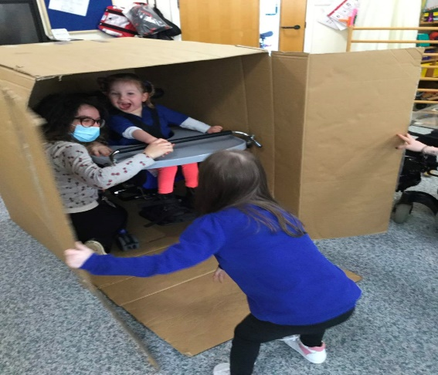

Finding your friend when playing hide and seek is the best fun!

We celebrated Conductive Education Awareness week (14th- 18th March). The week allowed us to celebrate the achievements of the pupils through their hard work and using CE as a learning tool. Some highlights from the groups …
- Talking about rhythm and how this affects the pupils’ tone e.g., they used a really fast/quick pace and saw what this did then tried a very slow pace and saw this often made our bodies sleepy.
- The pupils talked about why working in groups motivated them and what they enjoyed about group work.
- Teaching the children about different types of facilitation and how this helps them.
- Helping pupils identify their “Wow” moments and all the wonderful things they have achieved.

Learning Support Assistants – Tracy Baker (Lead LSA)
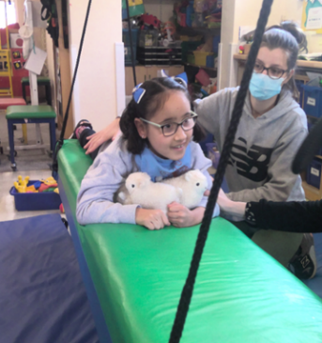
We are very happy to announce that we have been able to employ 2 play and independence care assistants, one on each site, 11.30am - 2.30pm. Kate Lawrence at Wendover Road and Louise Perrin at Coventon Road; this exciting role is both new to them and us at Pace.
The students have enjoyed expressing their wishes of what or who they want to play with at lunch time, Kate and Louise will support their wishes by making resources available or taking the lead on supporting the group, to either play together or individually. Both Kate and Louise will also attend our full induction training.
Occupational therapy – Jo Elliott (Lead Occupational therapist)
This term, our occupational therapists (OTs) have collaborated with our speech and language therapists (SLTs) and an external mental health specialist. Together, they have been looking at ways to expand the mental health support offered in Pace school and are currently piloting a psychoeducational therapy group with some of the secondary students. The aim of the group is to help the students develop better self and emotional awareness using the principles of cognitive behavioural therapy to explore the relationship between their thoughts, feelings and behaviours and to provide them with the communication skills and regulation strategies to express and manage these effectively.

The students have responded really well and are showing active participation and engagement. OTs are also looking into the potential for one to one sessions for more targeted mental health work and are supporting the ongoing training and upskilling of the class staff.

We are also delighted that Sarah Wimpenny Smith (OTA) has successfully completed the mental health first aid at work training and know she will utilise this well to support staff and students.

In conjunction with the physiotherapy team, we have been re-assessing how we meet the sensory motor needs to ensure every child is incorporating all the lovely movement opportunities we know support their development.
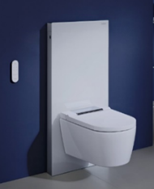
Our OT teams have also ‘gone back to basics’, with a great training session on bottom wiping
and are delighted that the school now have a wash dry toilet, in situ at Wendover Road:
Click here to find out more: Wash dry toilet

OTs are also trialling the Rifton support station at Coventon road – click here to find out more:
Support Station - Jiraffe

These new bathroom aids are proving popular with the students; If you are considering options for home you would be welcome to come and take a look or even try out! Please contact your class OT or Luke Thompson on luke.thompson@thepacecentre.org to arrange a suitable time to discuss further.

Teachers - Polly Kempson (Lead Teacher)

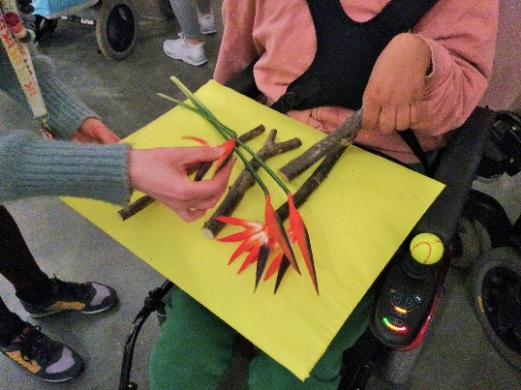
It has a been a busy spring term, with lots of inspirational activities going on throughout the school.

As part of their World of Work project, Rowan class visited MK Gallery to find out about their range of art activities and about the different jobs people do there. The students asked some great questions and enjoyed the sensory tour of the main exhibition.

This term primary students have been learning all about Animal Lives. We have been exploring different types of animals and the places they live in.

In Willow class we have enjoyed sensory trays, story writing and creative tasks that have helped us to learn more about animal habitats. We have also been exploring positional language and hiding lots of animals in our classroom.

We are really proud of our awesome story writing, we have been using beginning, middle and end to create interesting animal stories. In Elder class we have been thinking about Minibeasts in our Animal Lives topic. We have been enjoying lots of songs and stories about mini-beasts and we have been busy practicing with switches and using our hands to explore and learn. We have been really creative this term making mini-beasts out of all sorts of every-day objects such as socks and egg boxes!
Fundraising News!
The BIG Walk is back on Saturday 23rd April!

With a choice of four routes:
- 18m - Watlington to Wendover
- 12m - Chinnor to Wendover
- 6m - Princes Risborough to Wendover
- The Superhero Mile

Can you help to make this the best BIG Walk ever by:
- Signing up to walk?
- Spending a few hours volunteering?
- Spreading the word by putting up posters/flyers in your local community?
- Marking yourself as going or interested on the Facebook event page, then sharing it with family and friends

https://www.facebook.com/events/289718896462524?

However you can help will make a difference - THANK YOU!!

Sign up here https://thepacecentre.enthuse.com/cf/the-big-walk-2022

Message from the Pace Parent Partnership
We are happy to share the following message from the Pace Parent Partnership:
“The PPP are very excited to announce our Easter bonnet competition. The children are invited to make their Easter bonnets and bring them in to school on Thursday 7th April. There will be great prizes so please unleash your artistic side!”
Please see Parentmail message for more details.

Claire Smart
Headteacher

